CS 414: Graph Theory - Take Home Quiz
Name: Christian John L. Legaspi
Student ID: 2023302600
Section/Block: CS4B
1. Construct an undirected graph G = (V, E)
- Region Assignment: The last digit of my Student ID is 0. My region is Region XII (SOCCSKSARGEN).
- City Assignment: General Santos City.
- Vertices (V): I selected 10 coffee shops in General Santos City. The locations are from OpenStreetMap.
Vertex | Coffee Shop | Latitude | Longitude
S1 | Starbucks | 6.11561 | 125.18201
S2 | Starbucks (GenSan Highway) | 6.11926 | 125.18454
S3 | Bo’s Coffee | 6.11600 | 125.18175
S4 | Coffee Bean & Tea Leaf | 6.11618 | 125.18842
S5 | Cafe France | 6.11576 | 125.18117
S6 | Mac Greggor Coffee House | 6.11861 | 125.17717
S7 | Blu Gre Cafe | 6.11263 | 125.17467
S8 | Coy’s Cafe and Bar | 6.11298 | 125.17466
S9 | Dayspring Cafe (Yumang Street) | 6.13231 | 125.16119
S10 | Coffee Project (Albert Morrow Boulevard) | 6.16475 | 125.19653
V = {S1, S2, S3, S4, S5, S6, S7, S8, S9, S10}, so |V| = 10.
- Edges (E): I drew an edge {u, v} if the straight-line distance between u and v is 1 km or less.
Edge | Distance (km) | Edge | Distance (km)
{S1, S2} | 0.49 | {S2, S6} | 0.82
{S1, S3} | 0.05 | {S3, S4} | 0.74
{S1, S4} | 0.71 | {S3, S5} | 0.07
{S1, S5} | 0.09 | {S3, S6} | 0.58
{S1, S6} | 0.63 | {S3, S7} | 0.87
{S1, S7} | 0.88 | {S3, S8} | 0.85
{S1, S8} | 0.86 | {S4, S5} | 0.80
{S2, S3} | 0.48 | {S5, S6} | 0.54
{S2, S4} | 0.55 | {S5, S7} | 0.80
{S2, S5} | 0.54 | {S5, S8} | 0.78
{S6, S7} | 0.72 | {S6, S8} | 0.69
{S7, S8} | 0.04
|E| = 23. S9 and S10 have no edges. S9 is at least 2.33 km from every other shop. S10 is at least 5.23 km from every other shop.
Degree of each vertex:
Vertex | Degree | Vertex | Degree
S1 | 7 | S6 | 6
S2 | 5 | S7 | 5
S3 | 7 | S8 | 5
S4 | 4 | S9 | 0
S5 | 7 | S10 | 0
Check: the sum of the degrees is 46 = 2 x 23 = 2|E|.
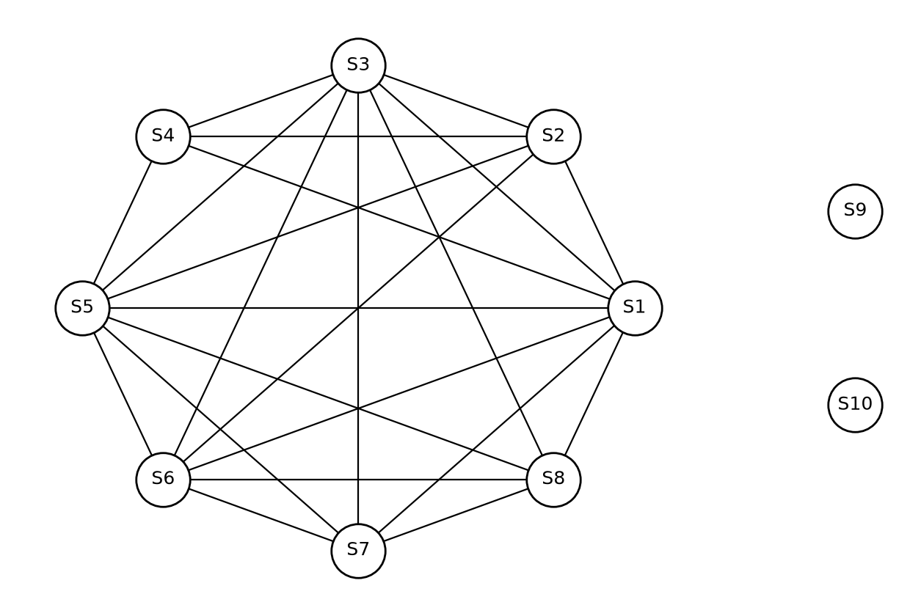
Graph G
2. Is the graph connected or divided into multiple components?
The graph is not connected. It has 3 components:
- Component 1: {S1, S2, S3, S4, S5, S6, S7, S8}. This is the downtown cluster.
- Component 2: {S9}. This is an isolated vertex.
- Component 3: {S10}. This is an isolated vertex.
Component 1 is very dense. It has 23 of the 28 possible edges between its 8 vertices. Its diameter is 2, so any shop in the cluster can reach any other shop in 1 or 2 steps.
This shows that General Santos City has one main commercial center. Most coffee shops are in the downtown area, close to the malls and the main highway. Outside the center, the city spreads out. The other shops (S9 and S10) are far apart and stand alone. So the city has one strong center and a spread-out area around it, not many commercial centers of equal size.
3. Would I open a new coffee shop in this city?
Yes. But I would not open it in the downtown cluster. I would open it in an area with few shops, like the northern part of the city near Albert Morrow Boulevard (near S10).
Reasons from the graph:
- Degree of a vertex. In the downtown cluster, S1, S3, and S5 have degree 7. This means each of these shops has 7 competitors within 1 km. A new shop there would also have a high degree, so it would share customers with many other shops. S10 has degree 0. A new shop near S10 would have at most 1 competitor within 1 km.
- Shortest path distance. In Component 1, the longest shortest path is only 2. The shops are packed close together, so that market is full. S9 and S10 have no path to the cluster (the distance is infinite in G). S10 is more than 5 km from the nearest downtown shop. People in that area have few choices nearby, so there is demand that the cluster does not serve.
- Connected components. The graph has 3 components, and 2 of them are single shops. This shows that the areas outside the center have very few coffee shops. A new shop there would start or grow its own small component and not join the crowded one.
Conclusion: The city has demand for coffee, because many shops survive in the center. But the center is full. The best decision is to open the new shop in an underserved area outside the downtown cluster, where its degree is low and the distance to other shops is large.

